Full Stack Development (FSD)
Documentation
ShopEZ — MERN Stack E-commerce Application

Phase: Project Documentation
TEAM ID : SWUID2026207177

Classification: Project Documentation — For Academic Submission
Full Stack Development with
MERN — Project Documentation
1
. Introduction
• Project Title
ShopEZ — A Production-Grade Full-Stack MERN E-commerce Platform

• Team Members
V S S S Manikanta — Lead Full-Stack Developer & Solutions Architect
Role: End-to-end implementation of backend API, database modeling, frontend SPA development, security orchestration, state management, and multi-service integration.

2. Project Overview

• Purpose
ShopEZ is developed to address key operational challenges in the modern e-commerce landscape. For small and medium-sized merchants, it provides a highly customizable and scalable online storefront to showcase products, manage inventory, and track orders. For end-consumers, it offers a fast, intuitive, and secure shopping experience with dynamic catalog filtering, persistent state retention, and multi-gateway payment processing.

• Features
User Management & Authentication: JWT sessions stored in secure HTTP-only cookies, combined with BCrypt password hashing and role-based access checks (Admin vs. Customer).
Dynamic Product Catalog: Pagination, keyword search, and filters (by category, price range, and rating) working without full-page reloads.
Persistent Shopping Cart: Syncs shopping cart items directly with MongoDB to retain user selections across multiple devices.
Secure Checkout Flow: A multi-step checkout wizard integrated with Stripe/Razorpay for secure card and UPI payment processing.
Admin Management Panel: Full CRUD operations for products, sales metrics charts, and status tracking for order fulfillment.
Media Handling: Ephemeral uploads optimized and served via the Cloudinary
CDN.

3. Architecture

• Frontend
The client is structured as a single-page application (SPA) using React.js. It features:
Context API: Handles global state for user authentication sessions and shopping cart items.
Axios Interceptors: Manages REST API communication, injecting credentials automatically and centralizing error notifications.
Responsive Styling: CSS variables and HSL palettes optimized for mobile, tablet, and desktop viewports.

• Backend
The server runtime is powered by Node.js and structured using Express.js in a strict Model-View-Controller (MVC) architecture:
Routing: Decoupled endpoints for users, products, and orders.
Middleware: Intercepts requests for authentication ( protect ), role checking ( isAdmin ), and global exception handling ( errorMiddleware ).

• Database
We utilize MongoDB Atlas as our cloud NoSQL data store, modeled and queried using the Mongoose ODM:
Data Integrity: Enforces strict schemas and validates inputs before writing to the collections.
Referential Constraints: Uses Mongoose ObjectId references to connect users, carts, products, reviews, and orders.
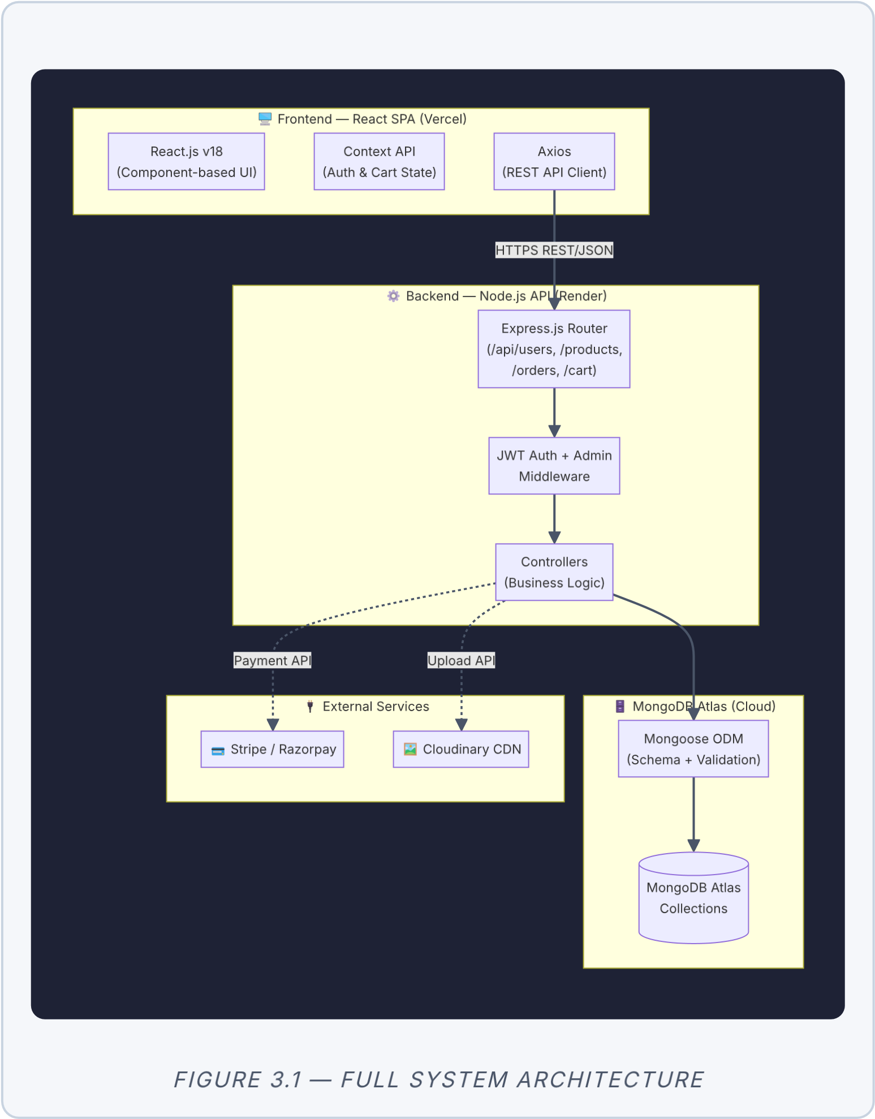
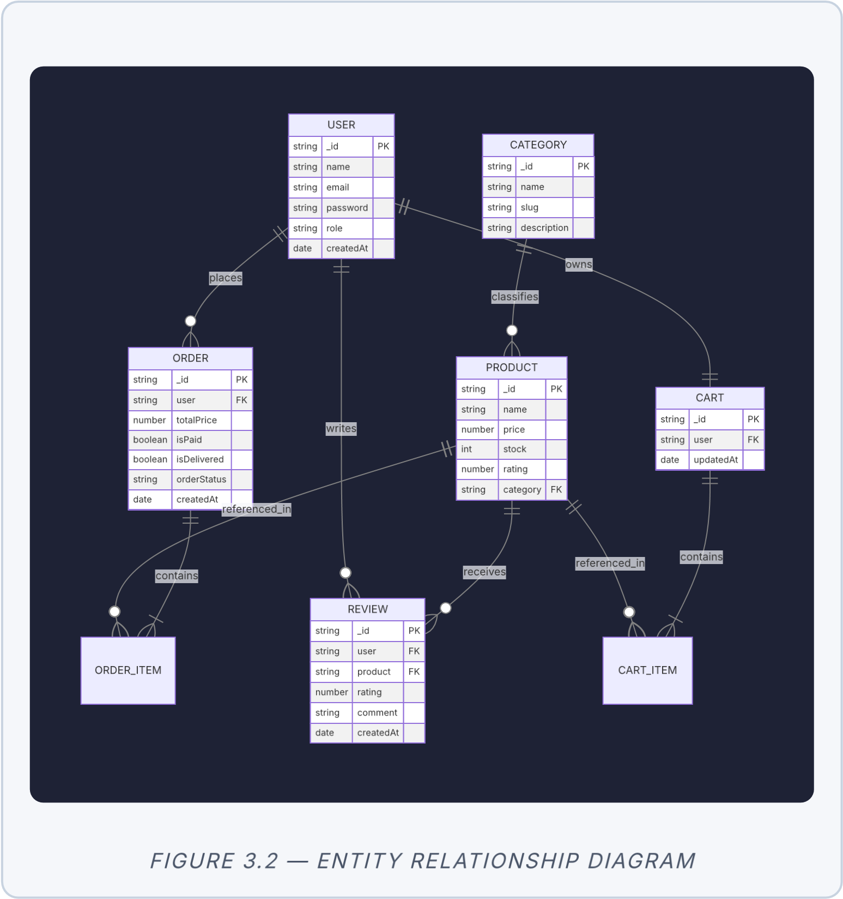
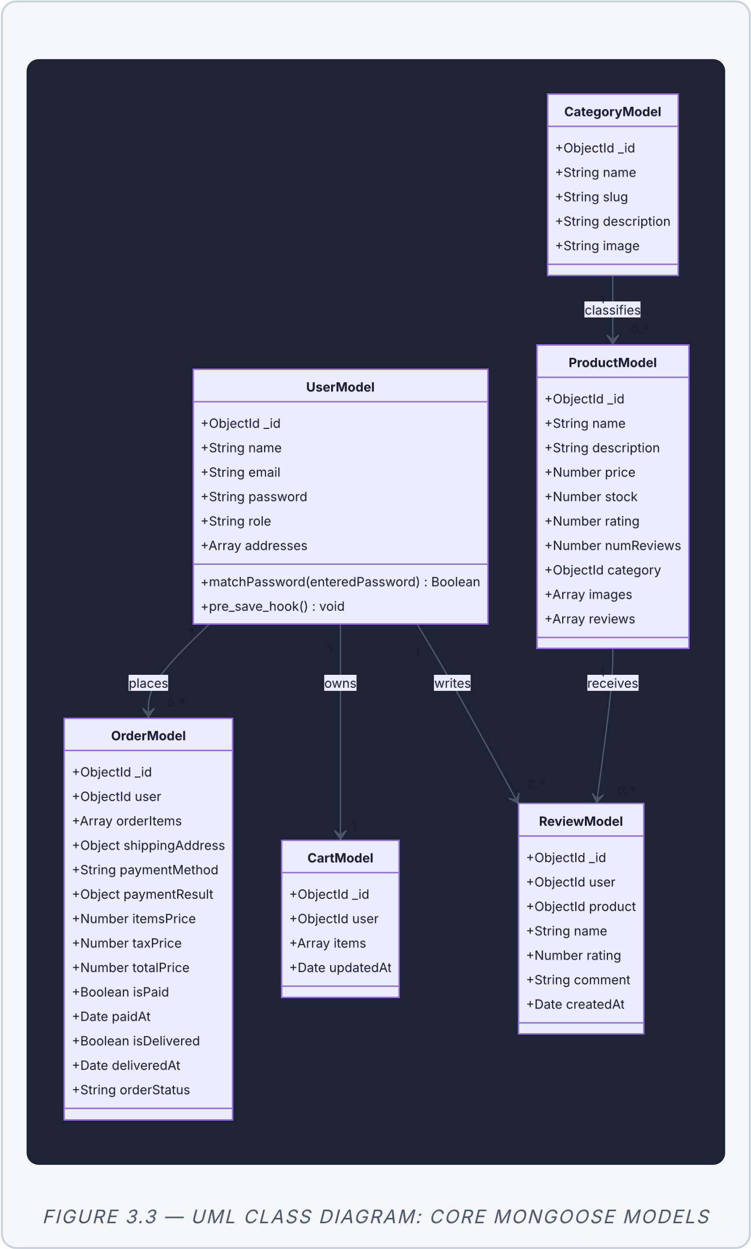

4. Setup Instructions

• Prerequisites
Node.js: v18 LTS or above installed.
MongoDB: A cloud cluster on MongoDB Atlas or local installation (v6.x+).
Package Manager: npm v9.x or above.
External accounts: Stripe account (for API test keys) and Cloudinary account (for media uploads).

• Installation
- Configure Environment Variables:
Create a .env file under the /server folder with the following variables:
PORT=8000
MONGO_URI=mongodb+srv://<username/:<password>@<cluster>.mo
JWT_SECRET=your_jwt_secret_key
STRIPE_SECRET_KEY=sk_test_your_stripe_key
CLOUDINARY_CLOUD_NAME=your_cloudinary_cloud_name
CLOUDINARY_API_KEY=your_cloudinary_api_key
CLOUDINARY_API_SECRET=your_cloudinary_api_secret
- Install Dependencies & Seed Database:
# Install server dependencies
&
seed DB
cd server
/&
npm install
/&
npm run seed
# Install client dependencies
cd
/
./client
/&
npm install

5. Folder Structure

• Client
client/
├── public/ # Static assets
└── src/
├── assets/ # Global CSS and themes
├── components/ # Reusable presentation parts (Nav
├── context/ # AuthContext.jsx & CartContext.js
├── pages/ # View routes (Home, ProductDetail
├── App.jsx # React routing setup
└── main.jsx # DOM mounting entry point

• Server
server/
├── config/ # db.js (Mongoose connection pool
├── controllers/ # User, product, and order control
├── middleware/ # authMiddleware.js & errorMiddlew
├── models/ # Mongoose schema definitions (Use
├── routes/ # Express REST endpoint routes
├── seeder.js # Database seeding script
└── server.js # Application entry file

6. Running the Application
To run the application locally in development mode, start both the backend API server and frontend development server:
Backend Server
:
Run in the
/server
directory:
npm start
(Default port: http://localhost:8000)
Frontend Server: Run in the /client directory:
npm start
(Default port: http://localhost:5173)

7. API Documentation
Method | Endpoint | Auth Required | Description
POST /api/users/register No Register a
new user account
POST | /api/users/login | No | Authenticate user & issue JWT cookie
POST /api/users/logout Yes Invalidate
user session & clear cookie
GET | /api/users/profile | Yes (Customer) | Retrieve authenticated user profile
PUT /api/users/profile Yes (Customer) Update user
profile data
GET | /api/users | Yes (Admin) | Retrieve a list of all users
DELETE /api/users/:id Yes (Admin) Remove a
user account
GET | /api/products | No | Get products (supports search, categories,  filters)
GET /api/products/:id No Get detailed
view of a single product

Method | Endpoint | Auth Required | Description
POST | /api/products | Yes (Admin) | Add a new product  listing
PUT /api/products/:id Yes (Admin) Modify a
product listing
DELETE | /api/products/:id | Yes (Admin) | Remove a product  listing
POST /api/products/:id/reviews Yes (Customer) Add rating and review comments
POST | /api/orders | Yes (Customer) | Place a new order
GET /api/orders/myorders Yes (Customer) Retrieve
personal order history
GET | /api/orders/:id | Yes  (Customer/Admin) | Retrieve order details by ID
PUT /api/orders/:id/pay Yes (Customer) Process
Stripe payment and set paid
status
PUT
/api/orders/:id/deliver
Yes
(
Admin
)
Mark

order
status

as
delivered
GET
/api/orders
Yes
(
Admin
)
View

all
customer
orders

8. Authentication
Authentication on the ShopEZ platform is stateless and utilizes JSON Web Tokens (JWT).
Token Issuance: When a user registers or logs in, the server generates a token signed with the JWT_SECRET .
Cookie Storage: The token is written directly to the response header as an HTTPonly, SameSite=Strict cookie. This prevents cross-site scripting (XSS) extraction and cross-site request forgery (CSRF) vulnerabilities.
Authorization
:
Protected routes use the JWT validation middleware
:
const protect = async (req, res, next)
/>
{
const token = req.cookies.jwt;
if (!token) return res.status(401).json({ message: 'Not au
const decoded = jwt.verify(token, process.env.JWT_SECRET);
req.user = await User.findById(decoded.userId).select('-pa
next();
}
;
9
. User Interface
The following screenshots showcase different UI features of the ShopEZ application:
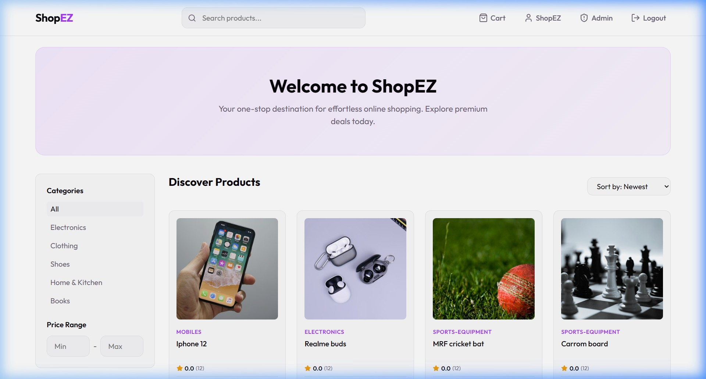

FIGURE 9.1 — SHOPEZ HOMEPAGE AND PRODUCT DISCOVERY GRID
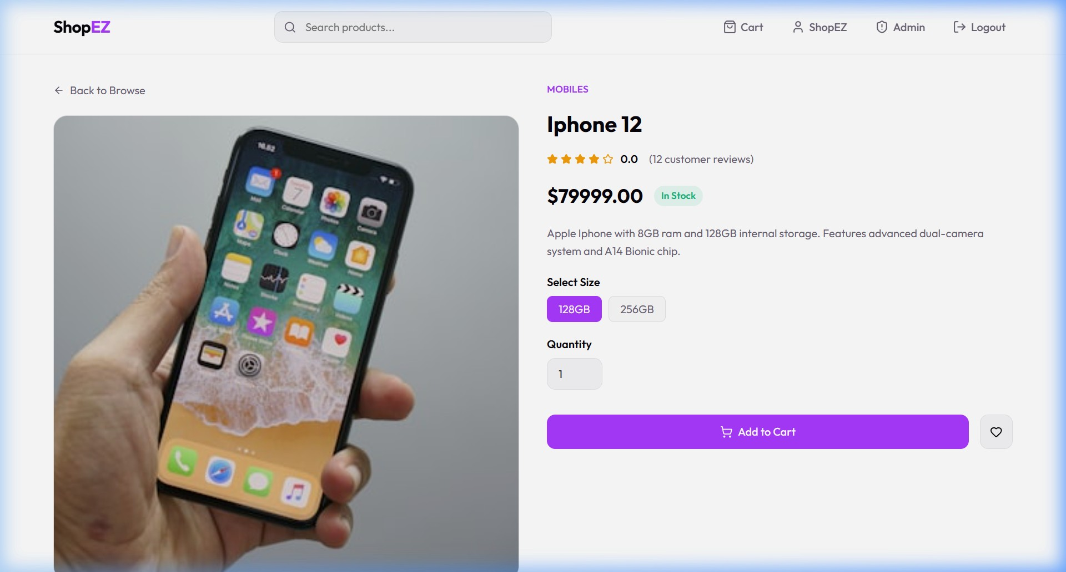

FIGURE 9.2 — PRODUCT DETAIL PAGE WITH RATING & REVIEW FORM
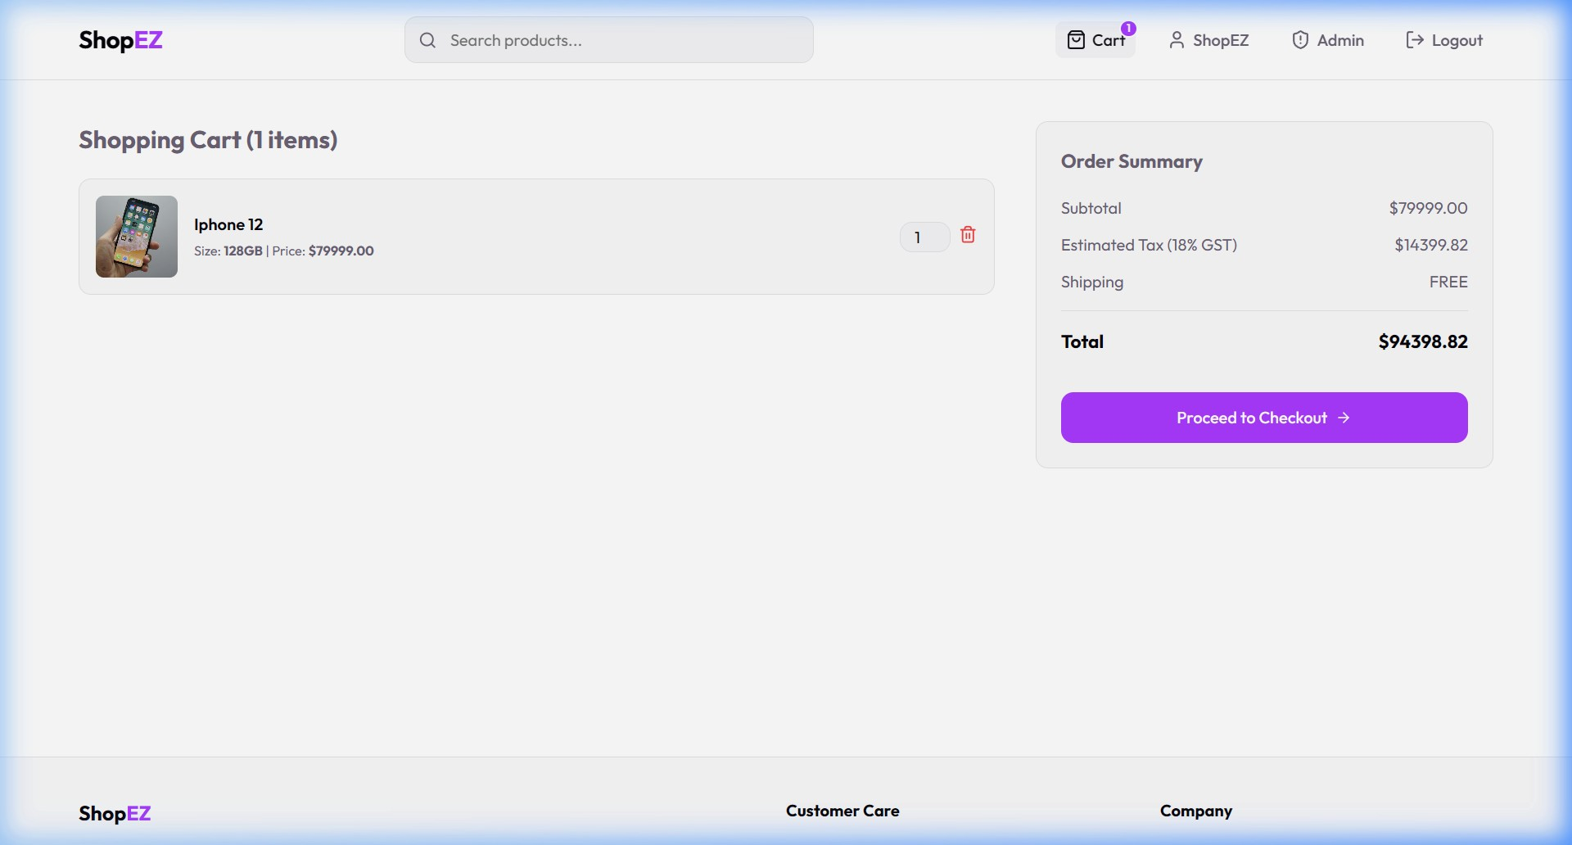
FIGURE 9.3 — SHOPPING CART SUMMARY AND PRICE ESTIMATION

10. Testing
The testing strategy for ShopEZ ensures reliability and correctness across multiple levels:
Unit Testing: Testing of utilities, validation rules, and context status reducers (Jest,
RTL).
Integration Testing: Running API request/response assertions using Postman and Newman collections to verify route security and status codes.
User Acceptance Testing (UAT): Execution of 16 defined manual UAT scripts covering complete user flow (Registration → Search → Cart → Checkout → Payment → Admin Inventory verification).

11. Screenshots or Demo
The platform is deployed online in a decoupled cloud environment. You can access the application and review the administrative features using the following credentials:
Resource | URL / Details
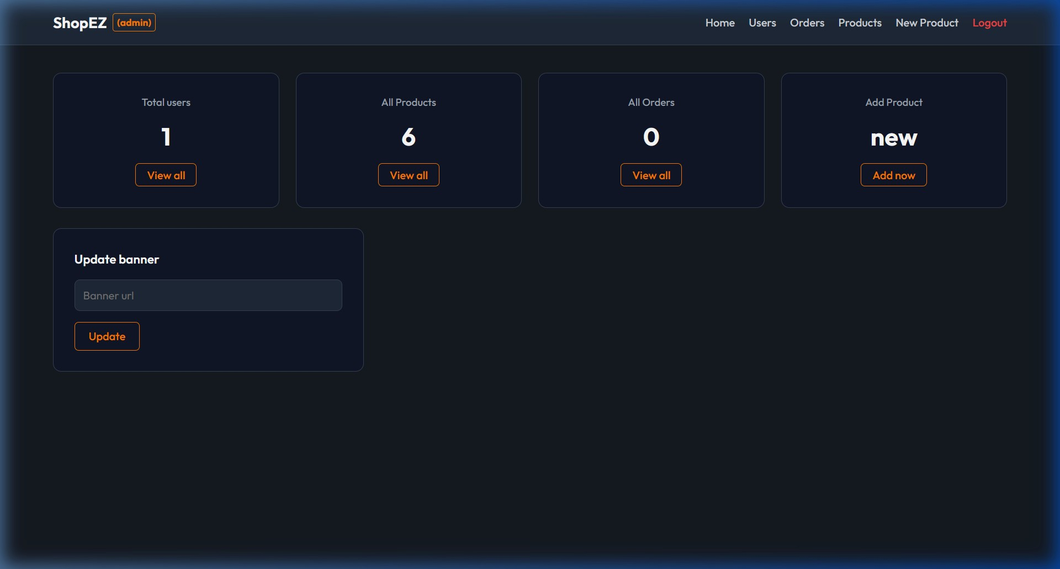
Live

Storefront
https:
/
/e-commerce-application-neon-
five.vercel.app/
Backend

API
URL
https:
/
/shopez-api-c30e.onrender.com
Customer
Account
test
@
email.com
/
password123
Admin

Account
admin
@
shopez.com
/
adminpassword123

FIGURE 11.1 — ADMIN PORTAL: PRODUCT CRUD AND INVENTORY ANALYTICS
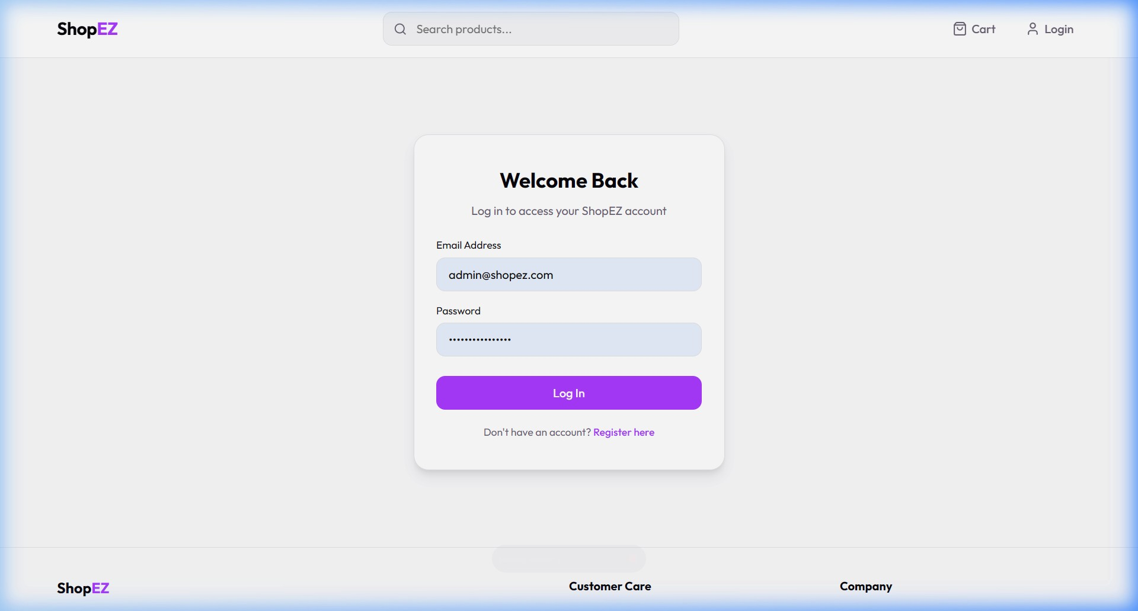

FIGURE 11.2 — CUSTOMER LOGIN INTERFACE
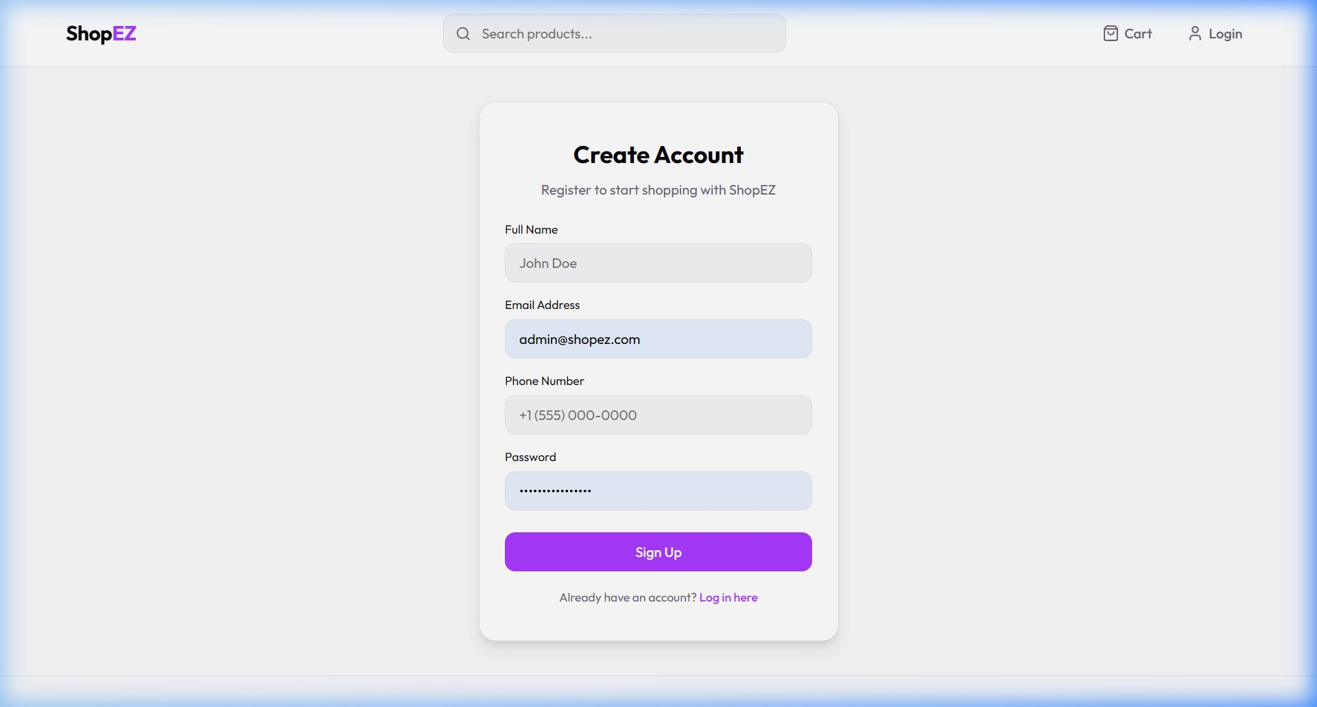
FIGURE 11.3 — CUSTOMER ACCOUNT REGISTRATION INTERFACE

12. Known Issues
Issue  ID | Description | Mitigation / Plan
KI-01 Cart state may desync on Server-side updatedAt
 | concurrent multi-device sessions. | timestamp comparison on cart save.
KI-02 | Render free-tier cold-start causes 30–60s initial delay. | Upgrade to paid tier for production hosting.
KI-03 | No email verification on user registration. | Add Nodemailer-based  verification flow in future release.

13. Future Enhancements
Priority | Enhancement | Description
Medium Email Alerts Nodemailer order dispatch
confirmations.
Low | Wishlists | Saved items library for customer accounts.
Future AI Recommendations Item-based collaborative filtering suggestions.
Future | React Native  Companion | Mobile application utilizing existing REST API.

ShopEZ MERN E-commerce Application · Project Documentation · Full Stack Development
(FSD) Documentation

